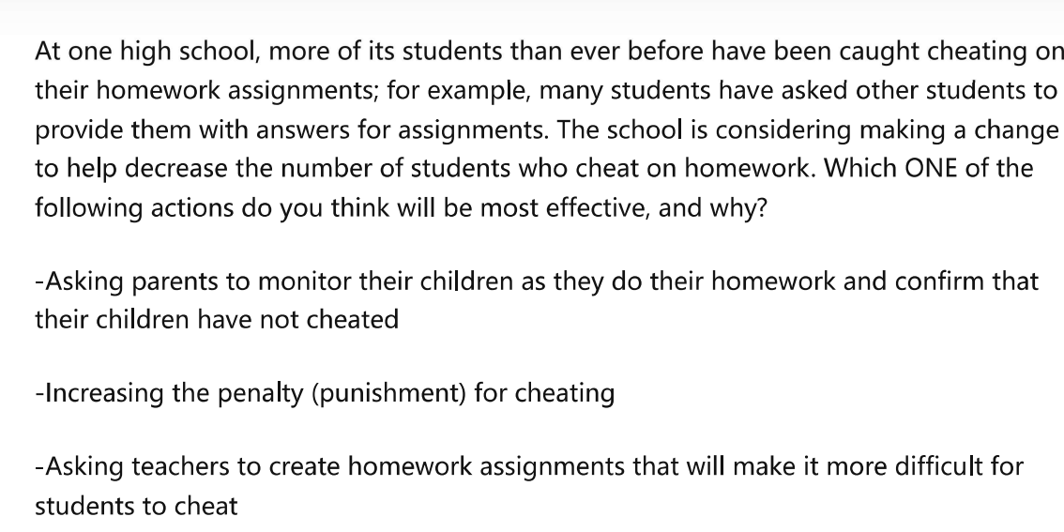

The basic characteristic of humans is laziness. Since the dawn of human civilization, hardly has there been an era that there was no cheating. Nowadays, some schools found out that the number of students cheating have increased significantly. Some people suggest to ask parents monitoring their children while doing homework, while others oppose by claiming it is better to ask teachers to create homework that is unable to cheat, or to increase the punishment on cheating. As far as I am concerned, it is best to increase the punishment compared to other practices. My reasons are as follows.

First and foremost, increasing punishment on cheating is able to increase student’s fear of cheating, thus decreasing the cheating rate. The most thing students fear is getting expelled from the school, since it will be a shame in their life, and their parents will get disappointed to them. In order not to let this happen, students will not cheat anymore. Take my class as an example, two years ago, almost half of our class cheat on their final exam. At that time, the punishment of cheating is just a paper of self-criticism. However, after the school had changed its punishment of cheating to expelling the student right away, no one ever cheat in my class on the latest mid-term exam, as everyone is afraid of getting expelled. This shows that impelling strict rules and punishments can help reduce cheating significantly.

Secondly, enforcing strict punishments on cheating can reduce it by boosting students’ self-control. Since cheating can not be forbidden by external forces, it is only students themselves who can stop cheating. By enforcing harsh punishments, students have nothing to choose but to study by themselves. A recent survey shows that after putting up strict punishments, nearly 88% student who cheat previously start to learn by themselves after their school carried out more strict punishments on cheating. This proves that it is best to waken students’ self-discipline by imposing strict punishments rather than other practices.

Admittedly, there are benefits for asking their parents to watch after students’ behaviors, or